Lab 9

Q1

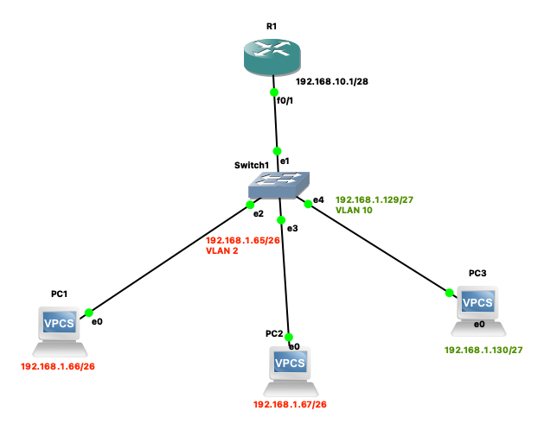Switch Configurations:

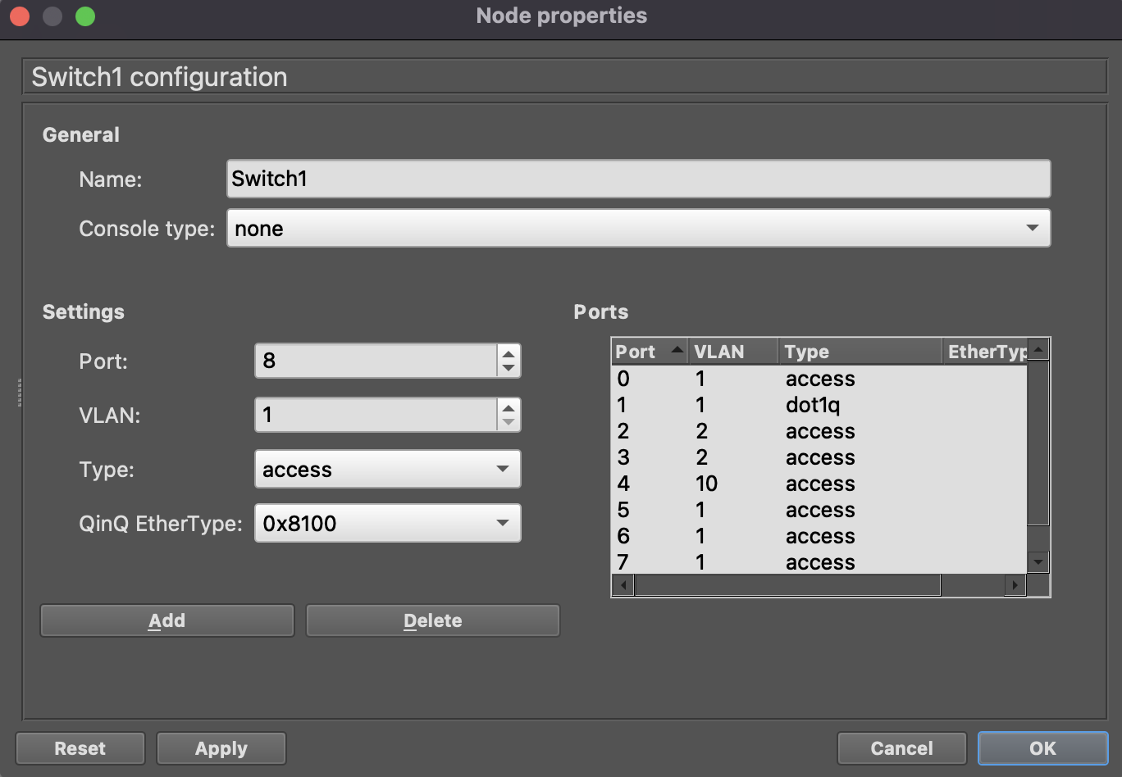

R1 configurations:

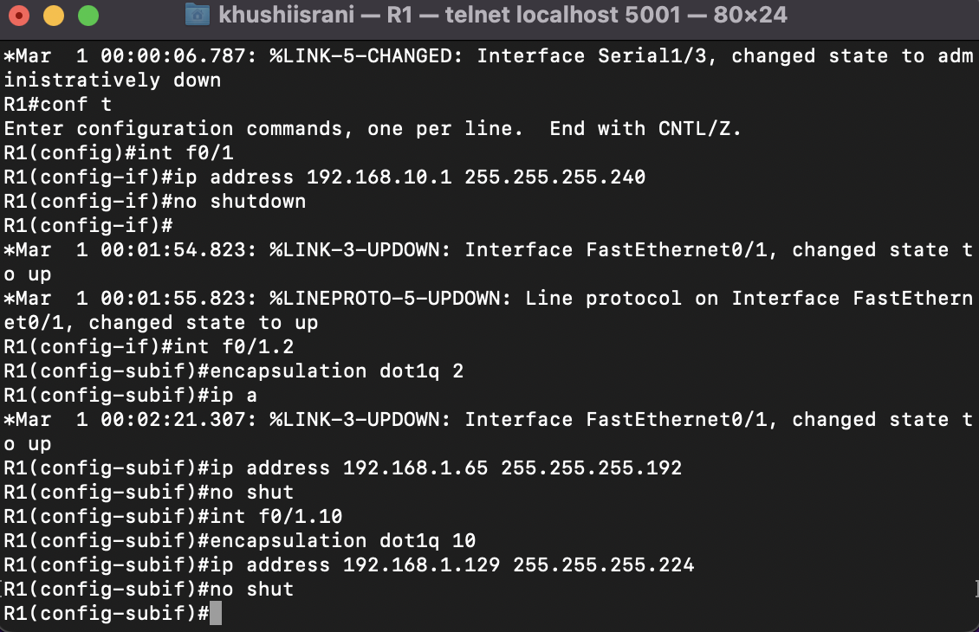

PC1 configuration

Also checking if it’s successfully connected to the VLAN switch I.e. pinging is successful

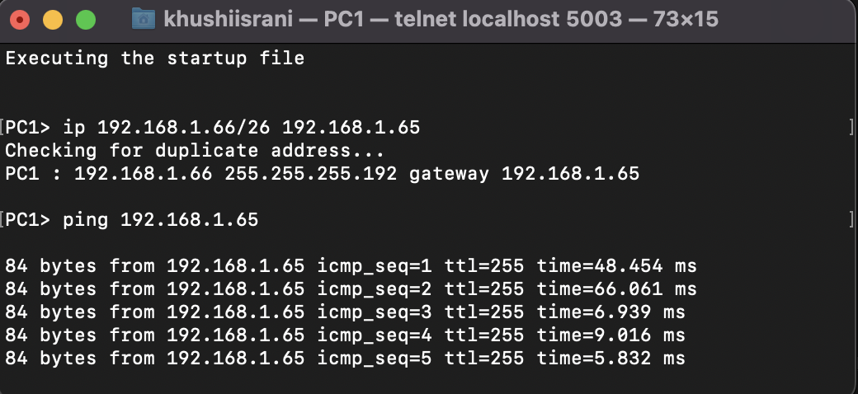

PC2 configuration

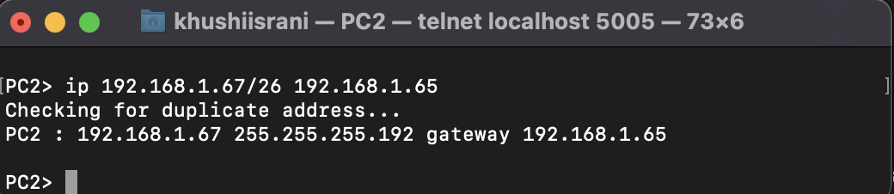

PC3 configuration

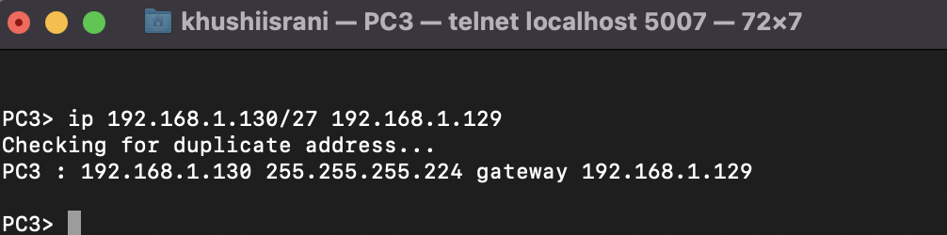

Pinging from PC1 to PC2 and capturing on Wireshark

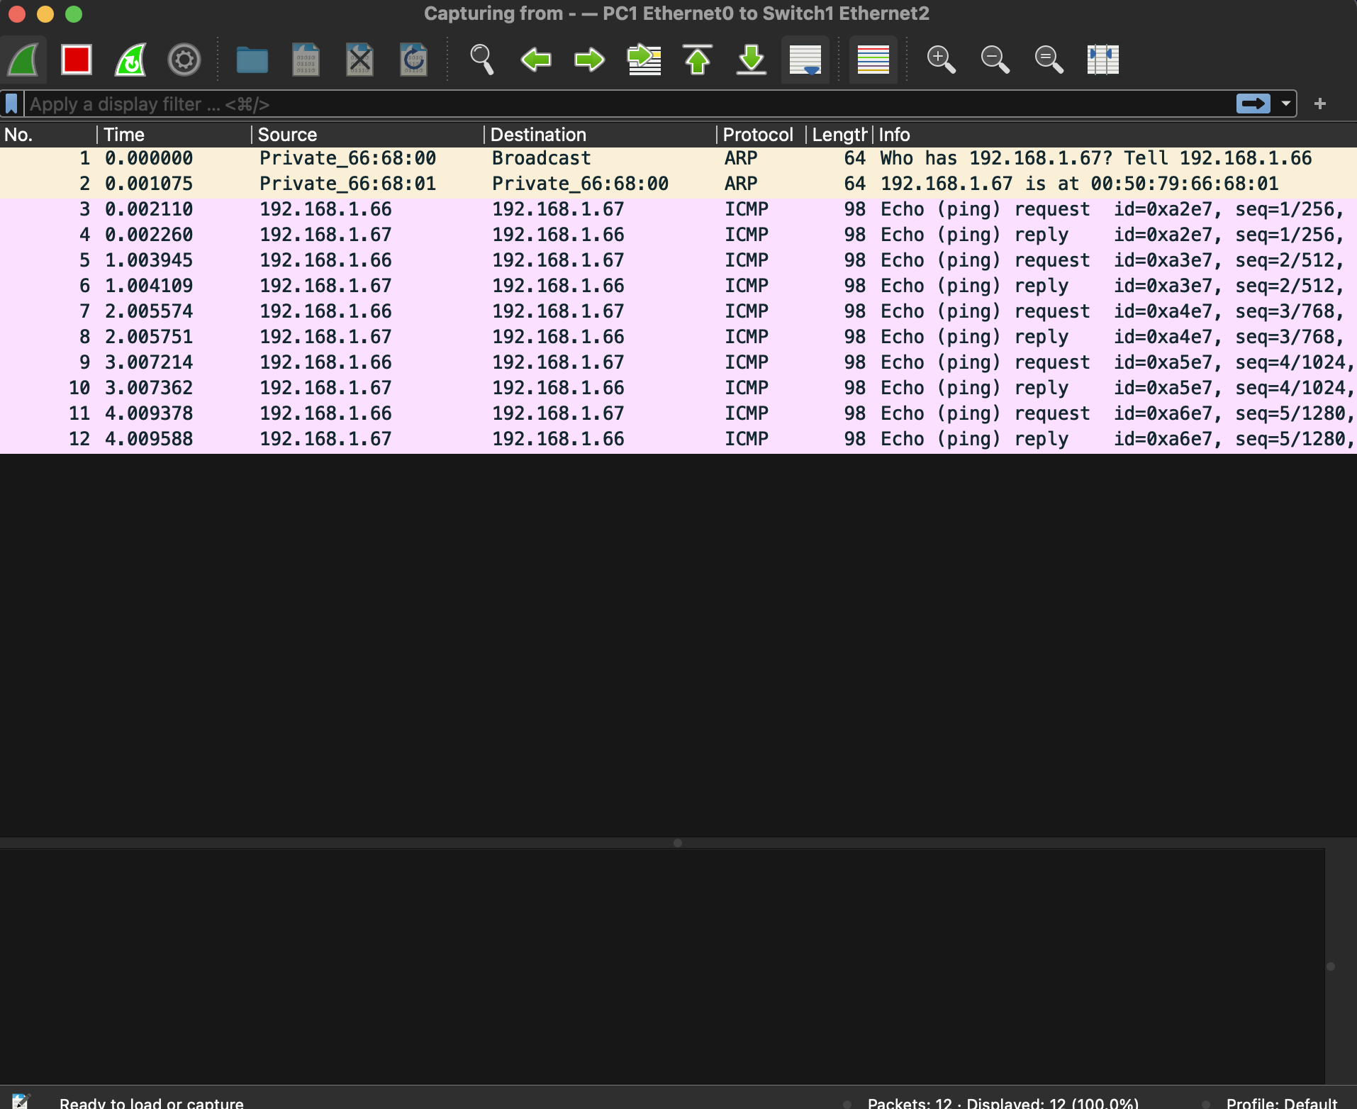

Pinging from PC1 to PC3 and capturing on Wireshark

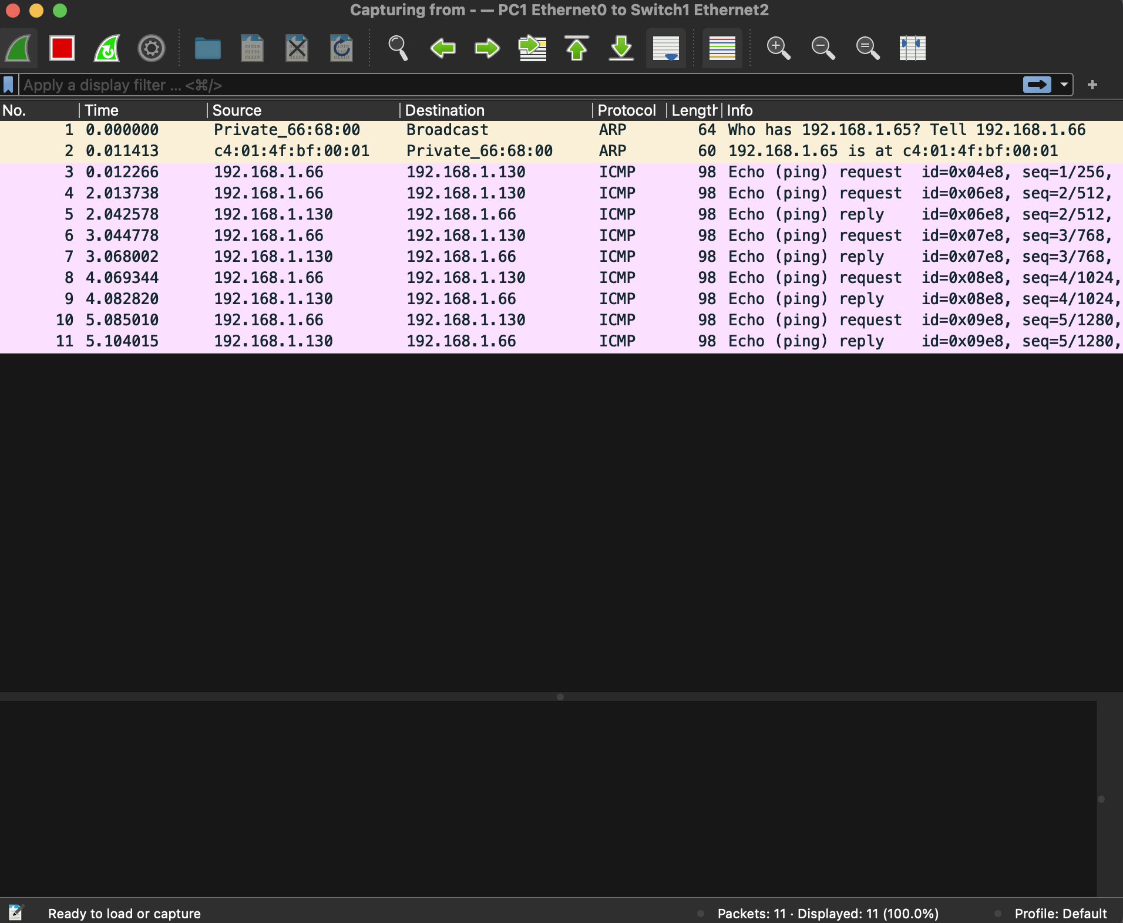

Classwork Question

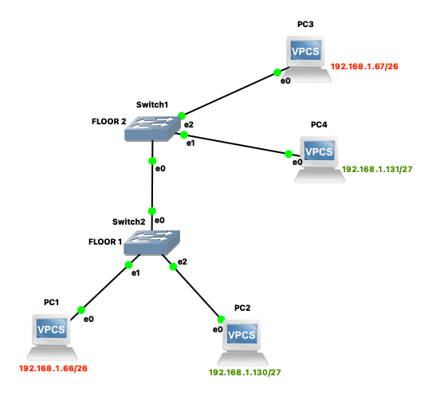

Switch1 configuration

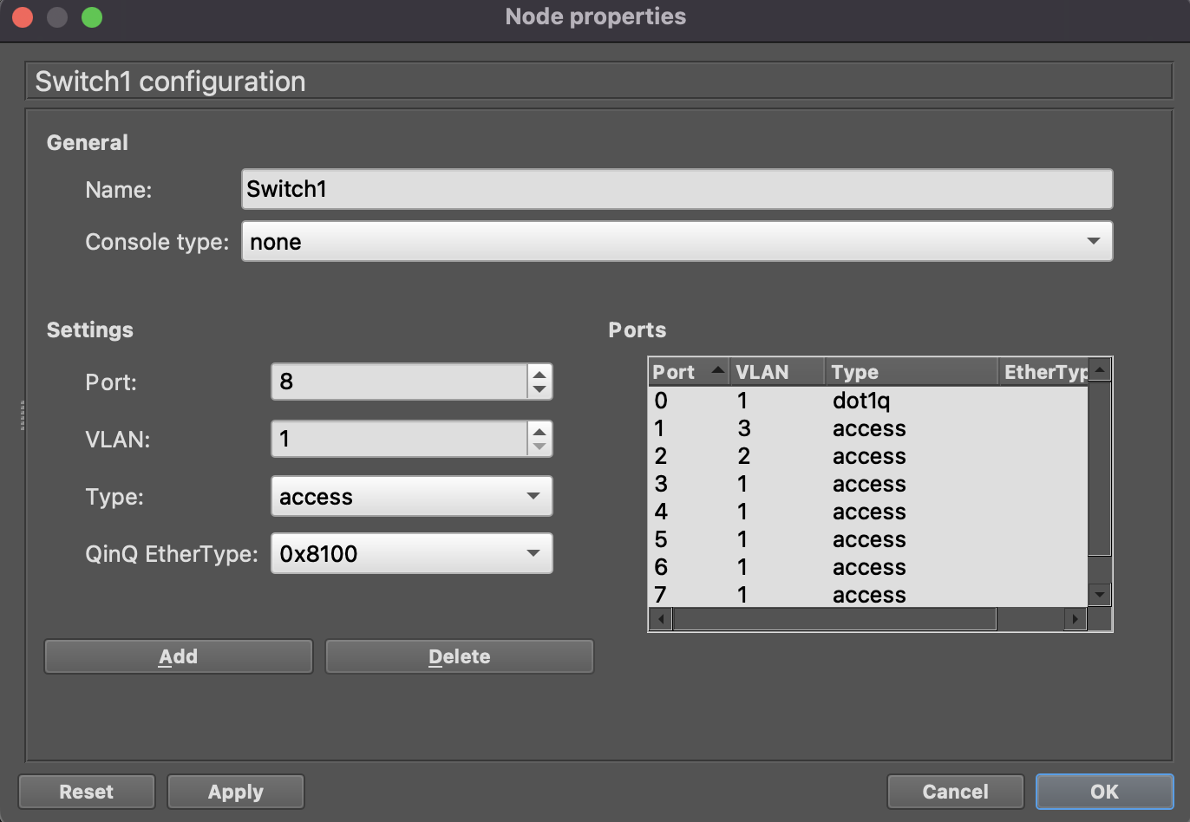

Switch2 configuration

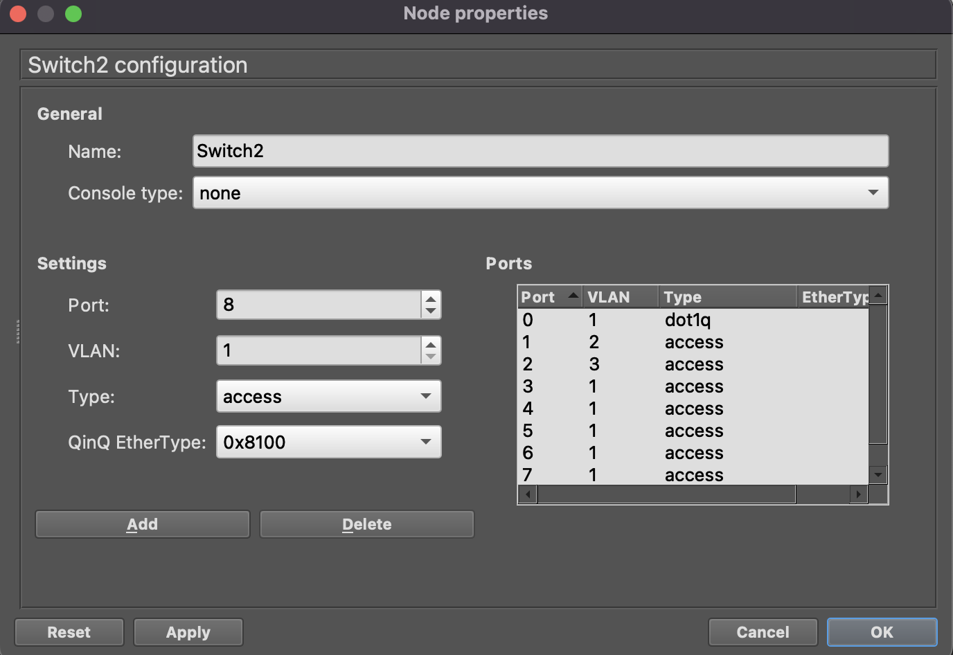

PC1 configuration

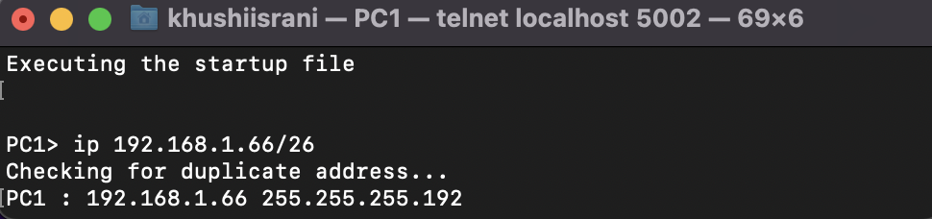

PC2 configuration

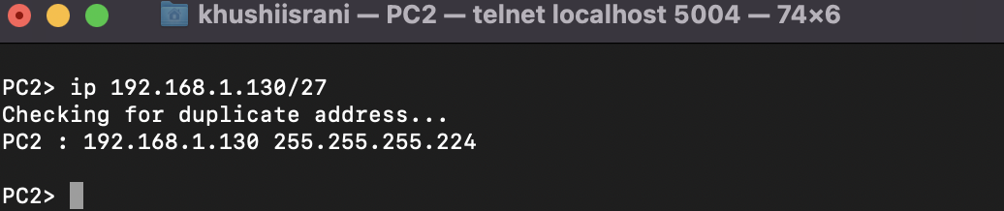

PC3 configuration

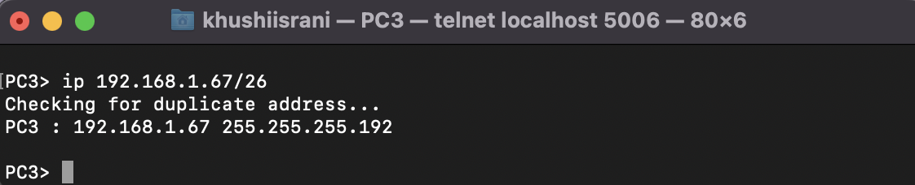

PC4 configuration

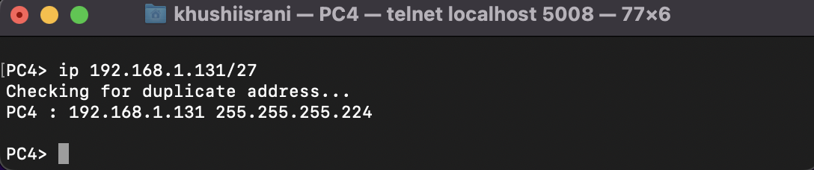

Pinging from PC1 to PC3 and capturing on Wireshark

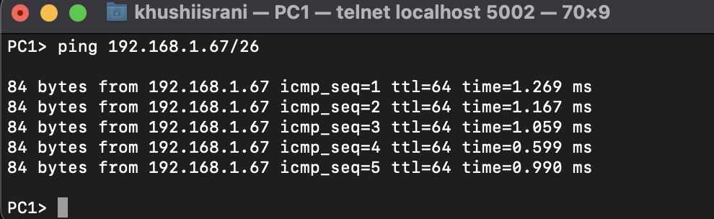

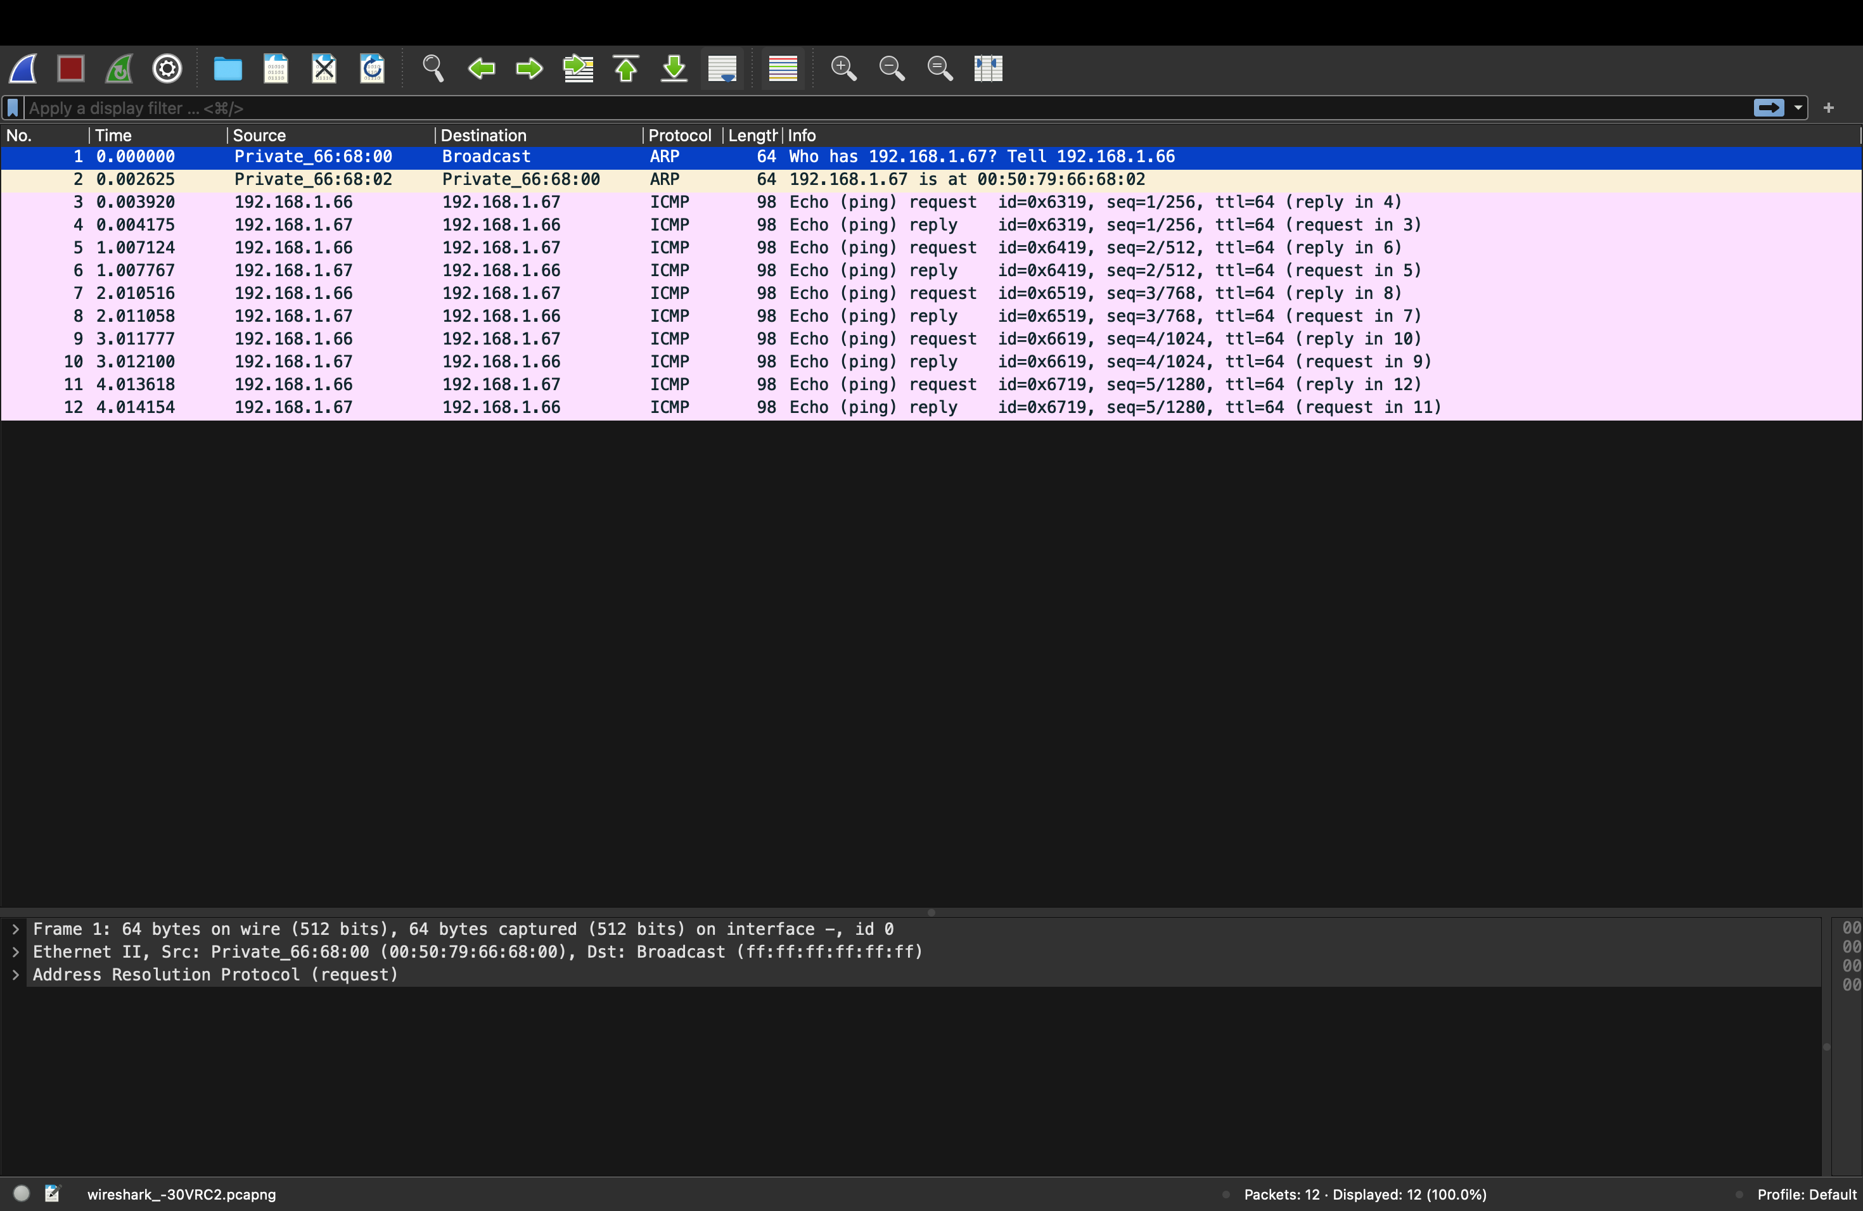

Pinging from PC2 to PC4 and capturing on Wireshark

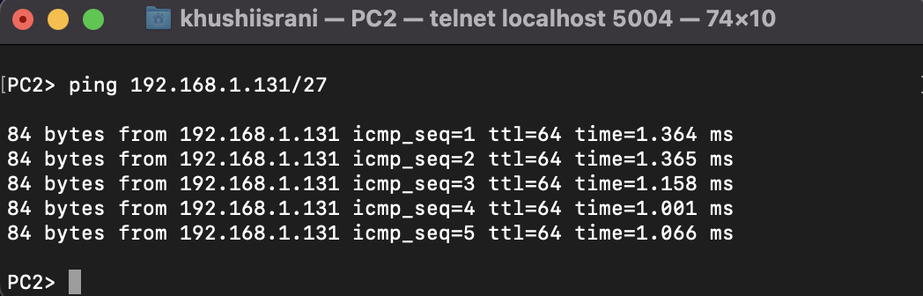

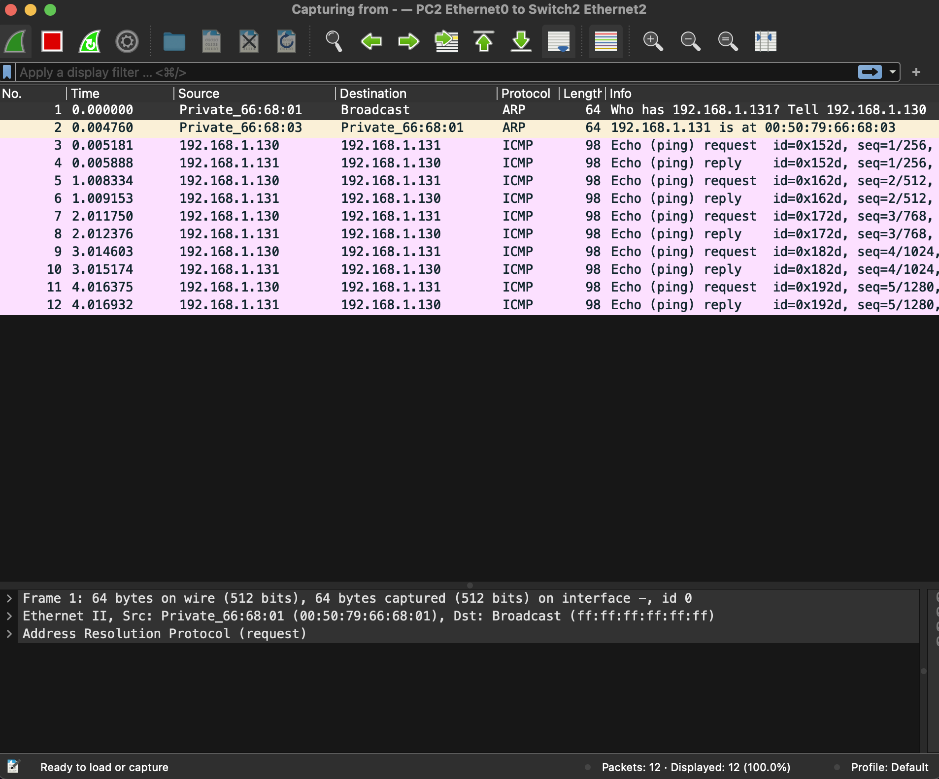

Lab question 2

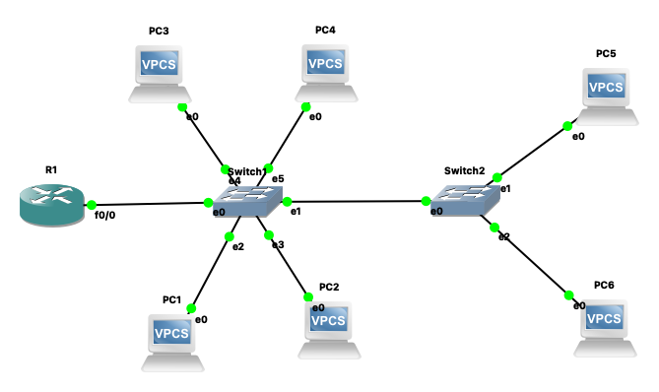

Switch 1 configuration

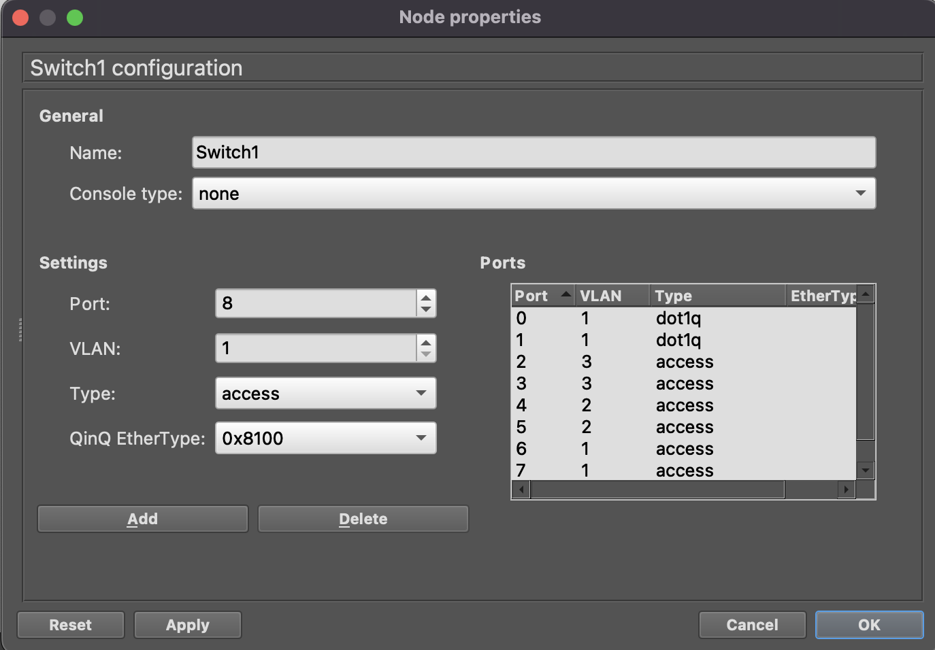

Switch 2 configuration

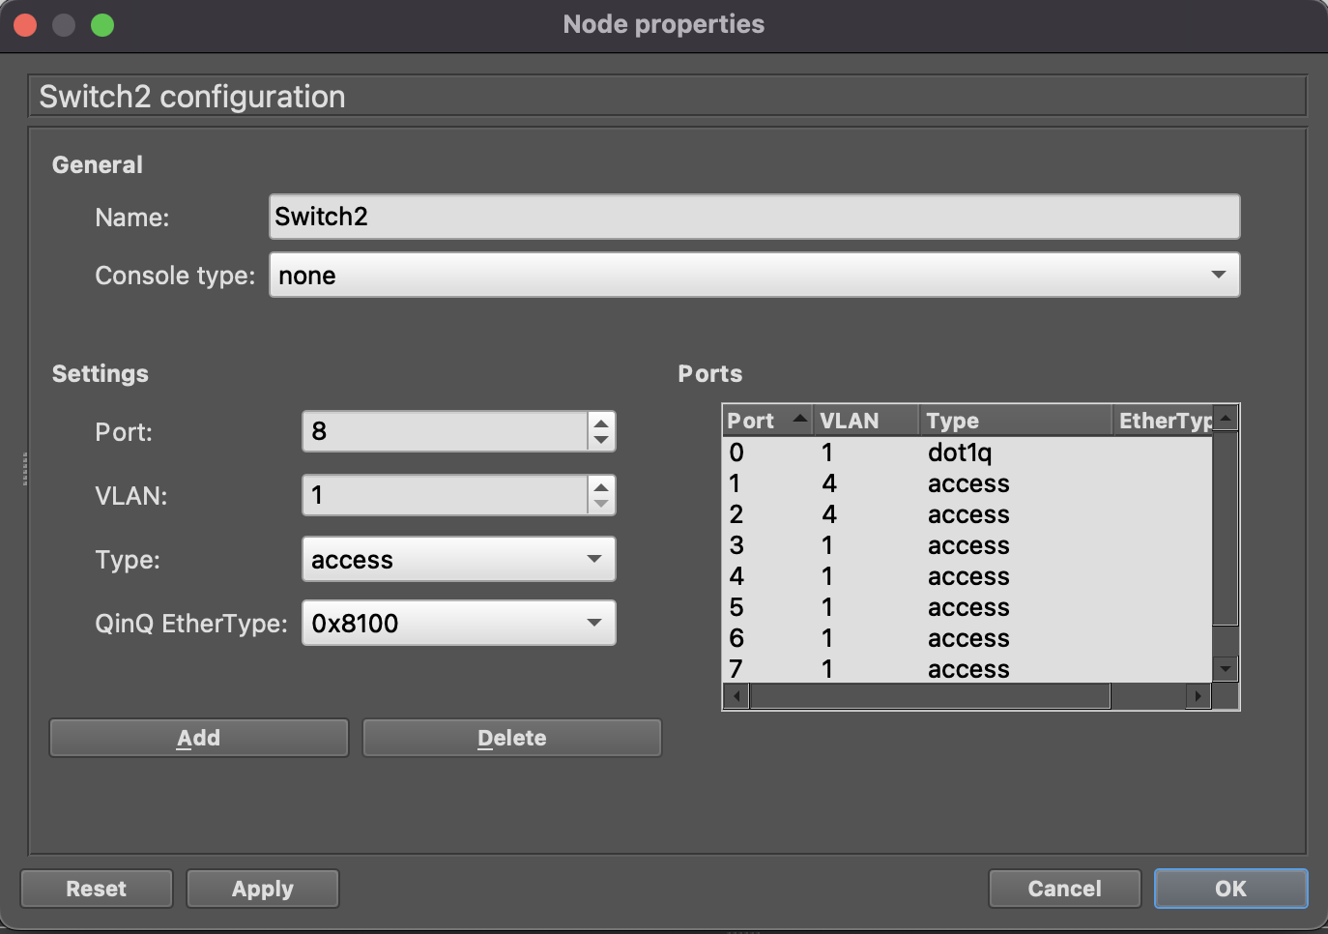

R1 configuration

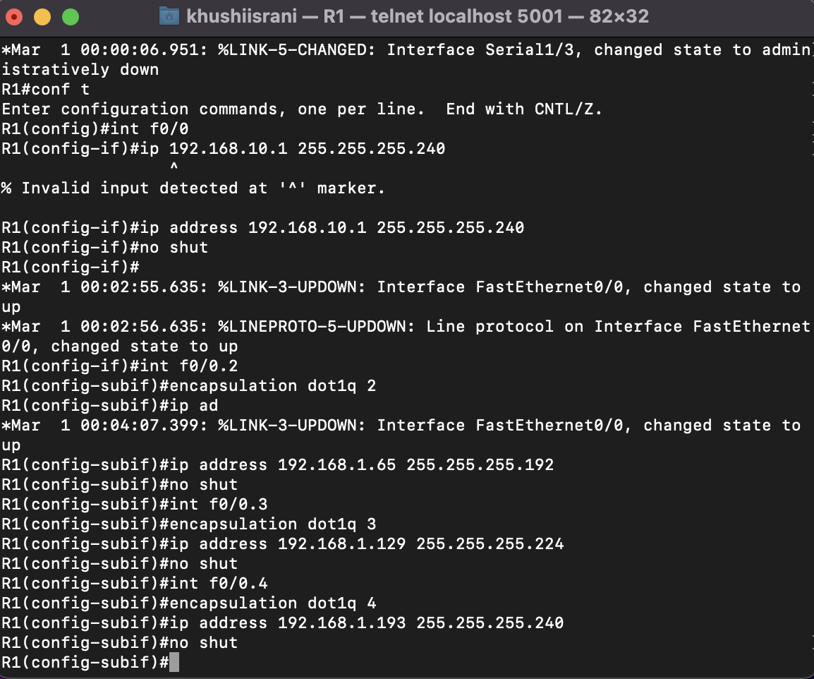

PC configurations

PC1> ip 192.168.1.130/27 192.168.1.129

Checking for duplicate address...

PC1 : 192.168.1.130 255.255.255.224 gateway 192.168.1.129

PC2> ip 192.168.1.131/27 192.168.1.129

Checking for duplicate address...

PC2 : 192.168.1.131 255.255.255.224 gateway 192.168.1.129

PC3> ip 192.168.1.66/26 192.168.1.65

Checking for duplicate address...

PC3 : 192.168.1.66 255.255.255.192 gateway 192.168.1.65

PC4> ip 192.168.1.67/26 192.168.1.65

Checking for duplicate address...

PC4 : 192.168.1.67 255.255.255.192 gateway 192.168.1.65

PC5> ip 192.168.1.194/28 192.168.1.193

Checking for duplicate address...

PC5 : 192.168.1.194 255.255.255.240 gateway 192.168.1.193

PC6> ip 192.168.1.195/28 192.168.1.193

Checking for duplicate address...

PC6 : 192.168.1.195 255.255.255.240 gateway 192.168.1.193

Pinging from PC1 to other PCs

